**Azure Solutions**

*Internet of Things*

Azure IoT (Internet of Things) is a comprehensive set of cloud-based services and solutions offered by Microsoft Azure to enable the development, deployment, and management of IoT applications and devices.

**

IoT hub

• Azure IoT Hub is a cloud service that connects millions of IoT devices to a solution back end. It acts as a central message hub for communication between IoT applications and their attached devices.

• It is a PaaS service

• It is a hub to collect data feeds from all your things.

• It is what is called a backend, meaning the system they receive the data and manages it. It can receive data from millions and according to Microsoft, even billions of devices.

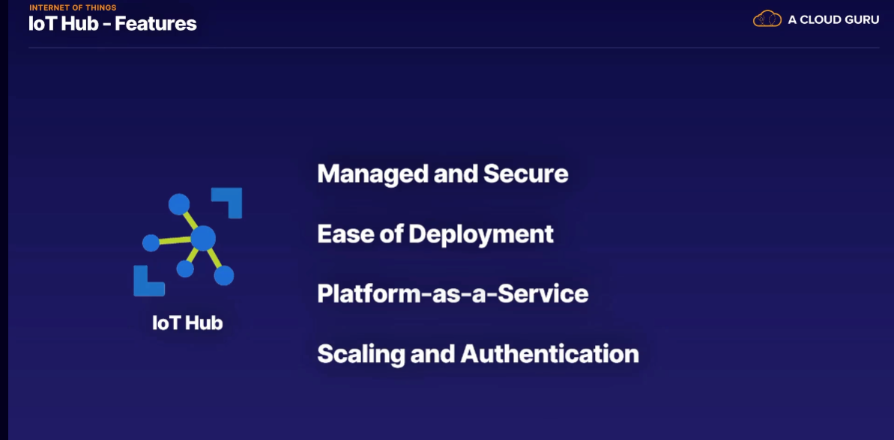

IoT Central

* It provides a ready-to-use user experience (UX) and API surface to connect, manage, and operate devices at scale.
* Azure IoT Central can help you reduce the cost and burden of developing, managing, and maintaining IoT solutions. It also allows you to quickly evaluate your IoT scenario and assess the opportunities it can create for your business.
* Azure IoT Central is an IoT application platform as a service (aPaaS)

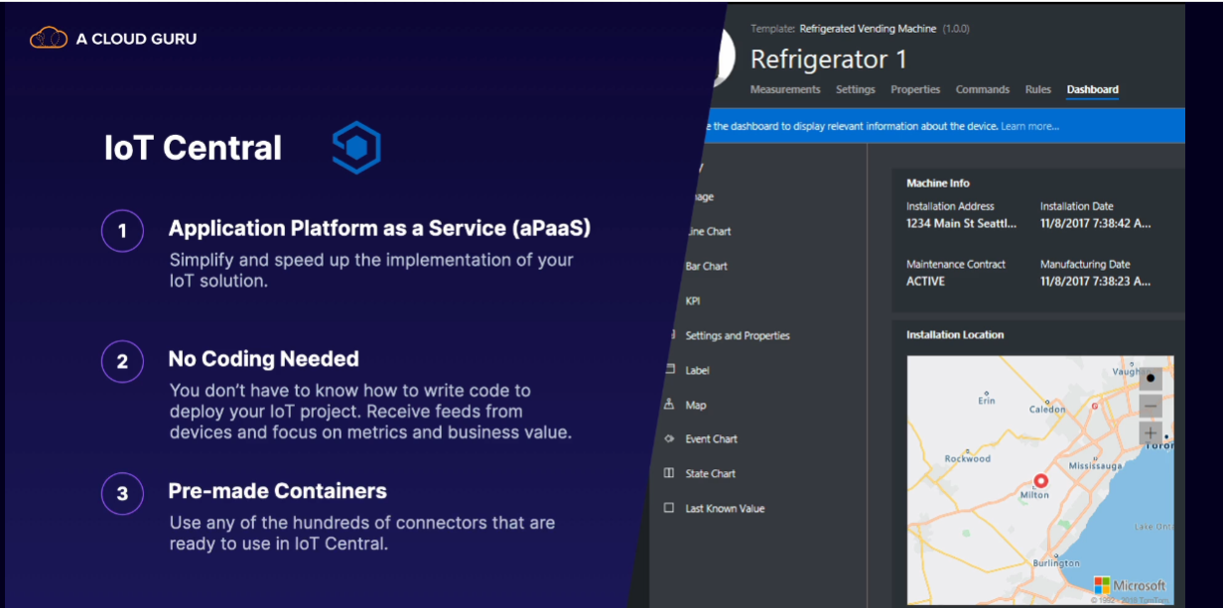

@ Use IoT Hub for solutions where you want more control of the whole process and how you collect and manage the data.

@ IoT Hub is a PaaS solution and creates a secure link for your data connections to the devices and make provisioning, that is getting them on the network and system, a lot easier to do for millions of devices.

@ IoT Central is an aPaaS solution that provides all the dashboards and infrastructure you need to create an IoT solution without any cloud nor IoT knowledge.

@ It is a tool with many ready-made components for you to set up.

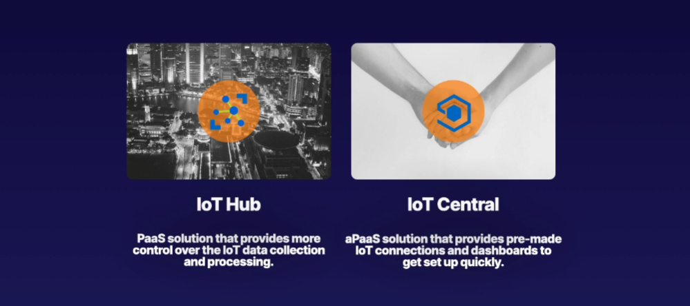

Azure Sphere

Azure Sphere is a secure platform for building Internet of Things (IoT) devices.

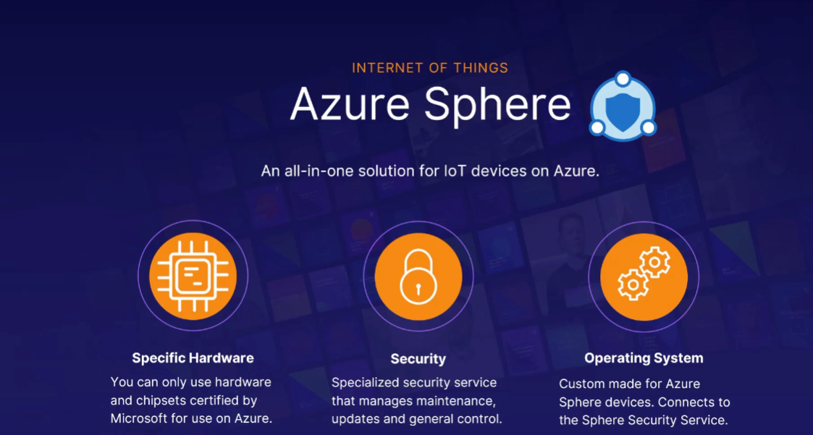

Sphere mandates what hardware you can use but then gives you security features and an IoT development platform in exchange.

Big data

* Big data analytics on Azure is a service that allows organizations to ingest, store, and analyze large volumes of data in real-time.

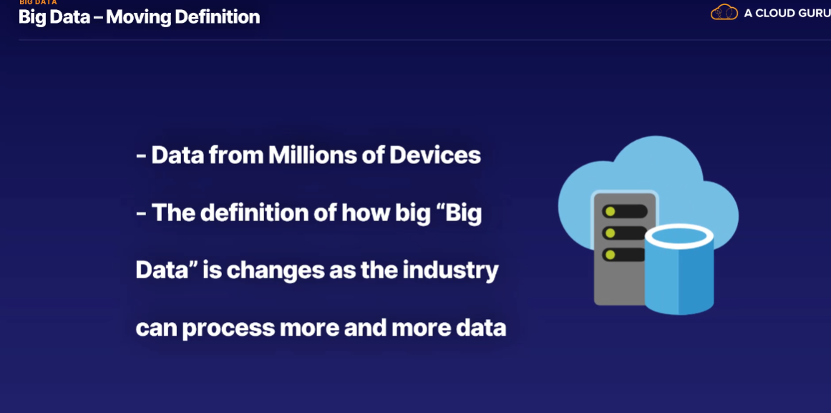

* Businesses want to get value from big data to provide better service, better products, and ultimately more profits.

There are so many tools and services are these to analyse the Bid Data

1. Data lake Analytics

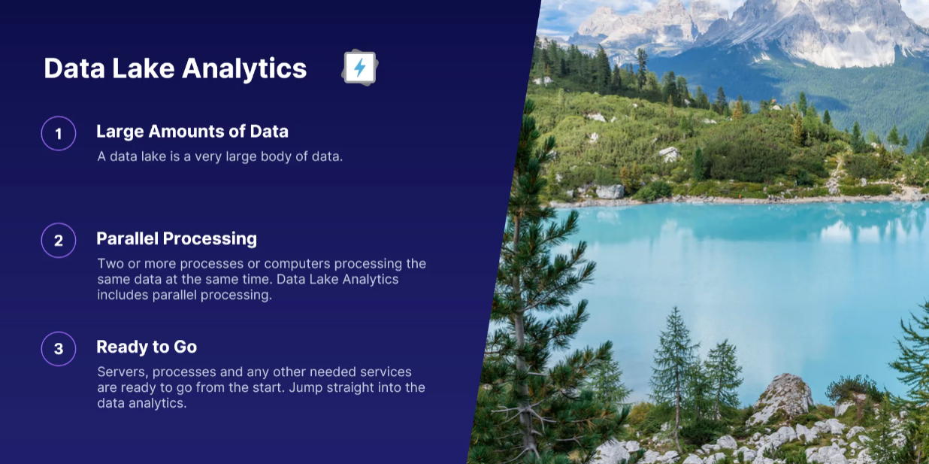

* Azure Data Lake Analytics is primarily a data processing service, not a storage service.
* It allows you to run data processing and analytics jobs on data stored in Azure Data Lake Storage or Azure Blob Storage.
* You write queries using U-SQL (a SQL-like language) to analyze and transform data stored in these storage services.
* Data Lake Analytics is suitable for data processing, transformation, and analytics tasks.

HD Insights

* This is similar to Data lake Analytics but this uses open source frameworks.
* Azure HDInsight is a managed big data platform that includes various data processing frameworks like Hadoop, Spark, Hive, and others.
* It provides clusters for running big data processing and analytics workloads.
* You can store data in various storage services, including Azure Data Lake Storage, Azure Blob Storage, or HDFS (Hadoop Distributed File System), and then process and analyze it using the frameworks supported by HDInsight.
* HDInsight is suitable for a wide range of data analysis tasks, including large-scale data processing, machine learning, and real-time analytics.

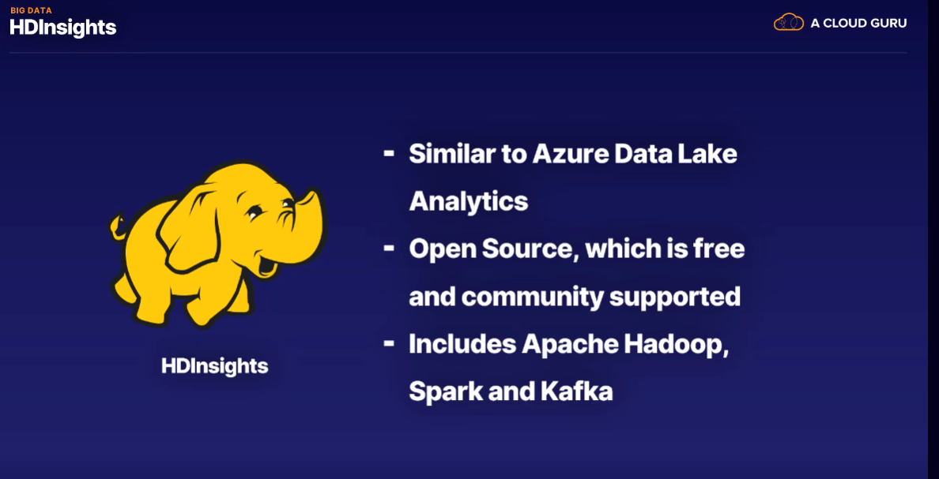

Data bricks

* Databricks is based on Apache Spark, which is an open-source distributed cluster computing framework.
* It means that Apache Spark can run on many computers at the same time and also process the same set of data on multiple computers at the same time.
* The advantage of using Azure Databricks is, that you don't need to buy lots of computers, nor maintain them.
* Azure provides the computing power and on top also offers a lot of integration points with all the other storage services on Azure, such as Storage, Analytics, and even Data Lake storage and Hadoop storage.
* You use data from all these data sources to find insights and analyze the data in Apache Spark or Azure Databricks, as it is called on Azure.

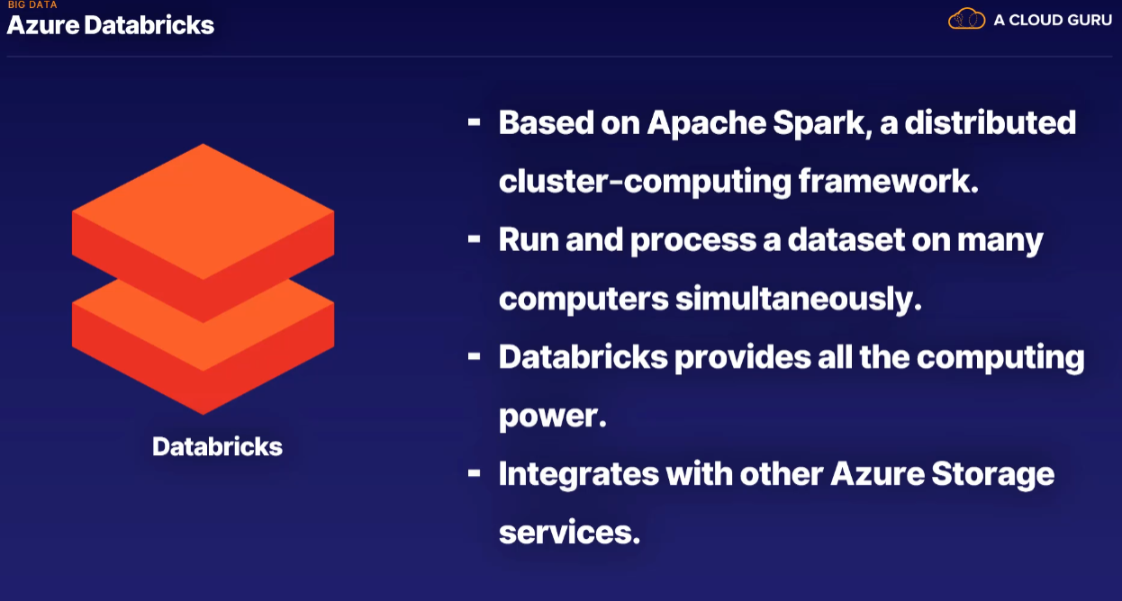

Azure Synapse Analytics

* This is the data warehouse solution for Azure. In fact, it used to be called Azure SQL Data Warehouse.
* Azure provides the Synapse SQL language, which you can use to cut, dissect, split, combine, and in any way mash up the data in any way you need.
* It's designed to provide organizations with a unified and integrated platform for big data and data warehousing.
* Azure Synapse Analytics brings together various data integration, data warehousing, big data analytics, and data exploration capabilities into a single service.

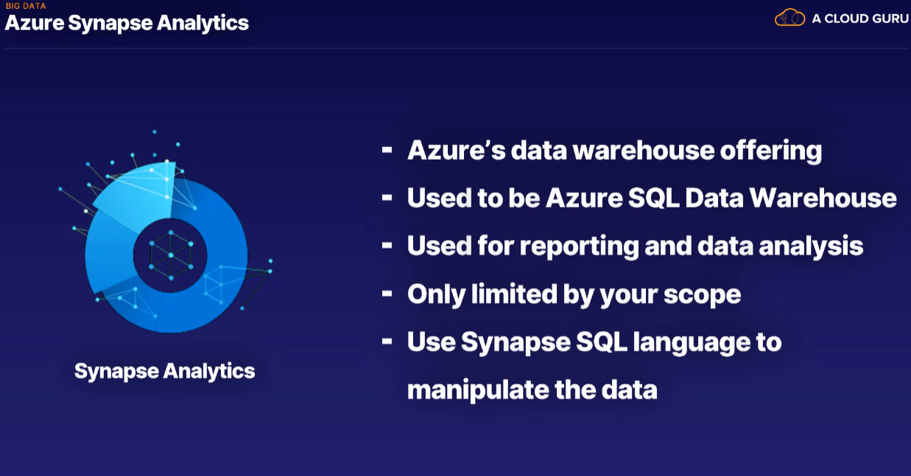

OUTCOMES

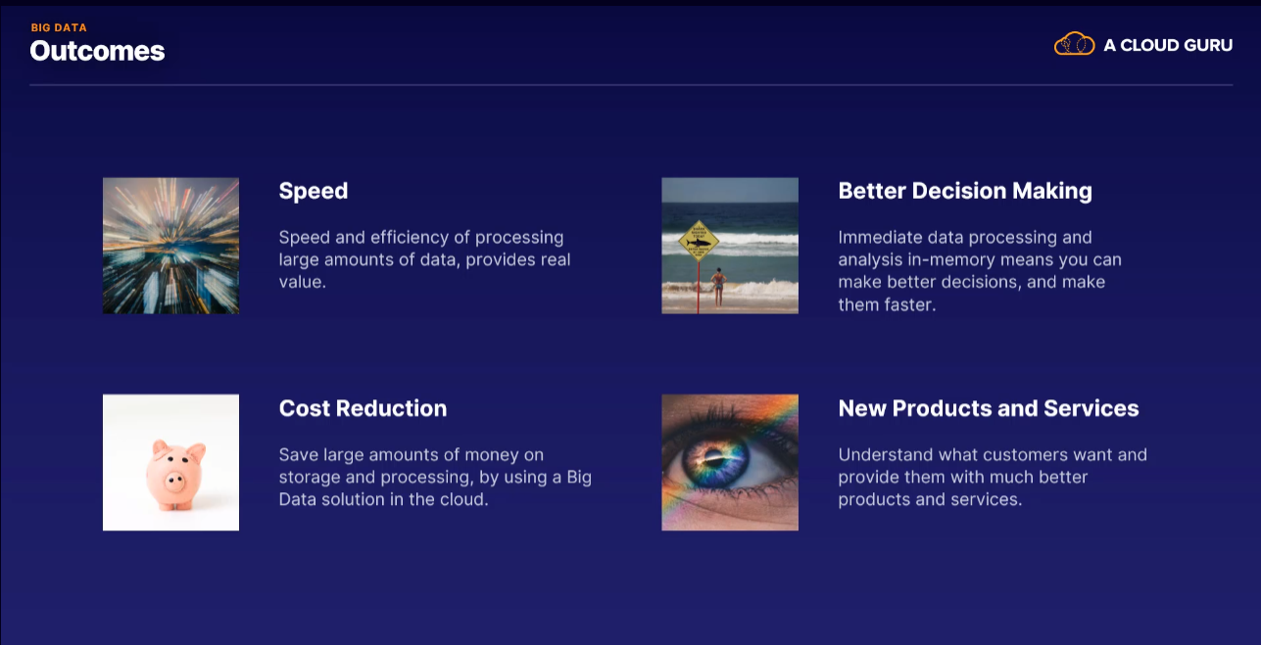

Machine learning

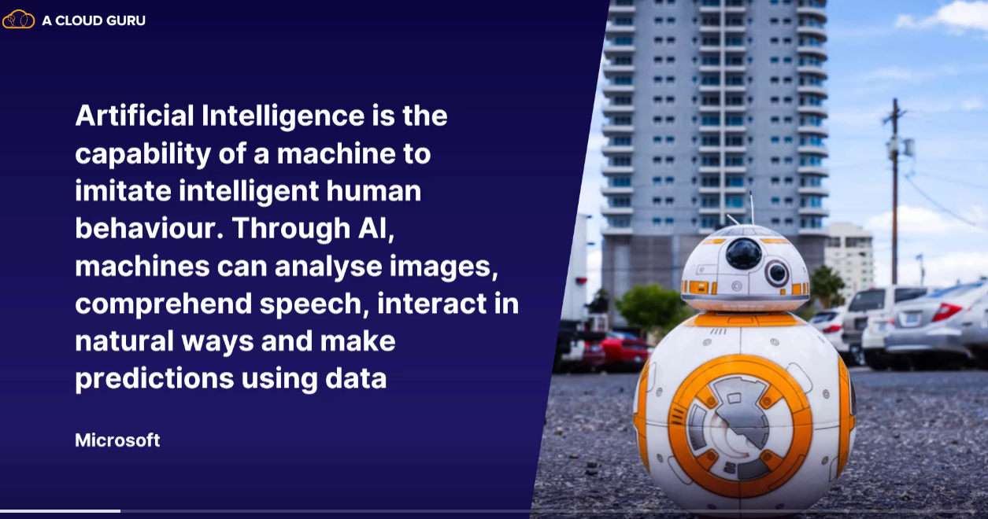

AI is most often called machine learning. Machine learning is a subcategory of AI, although they're often placed together in the same bucket.

Microsoft focuses on 3 main parts

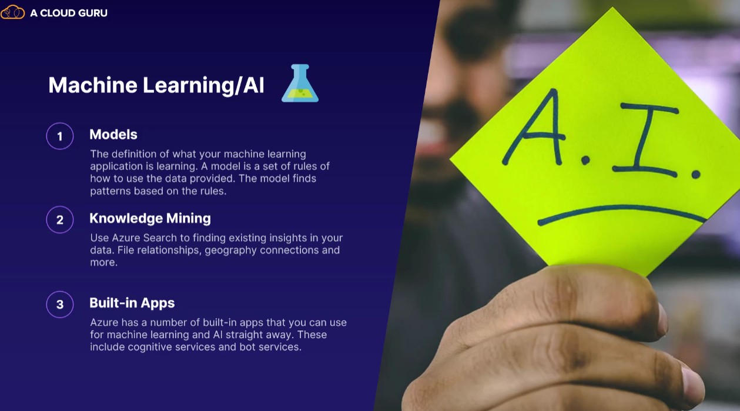

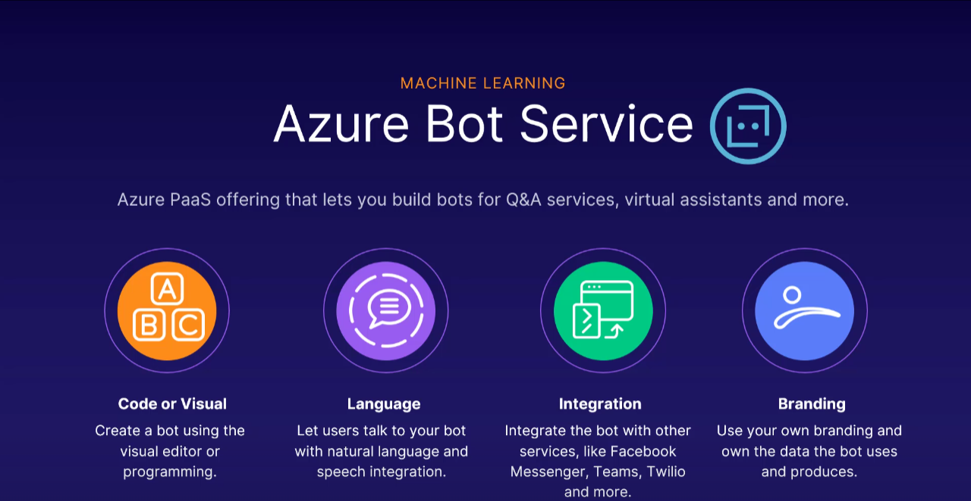

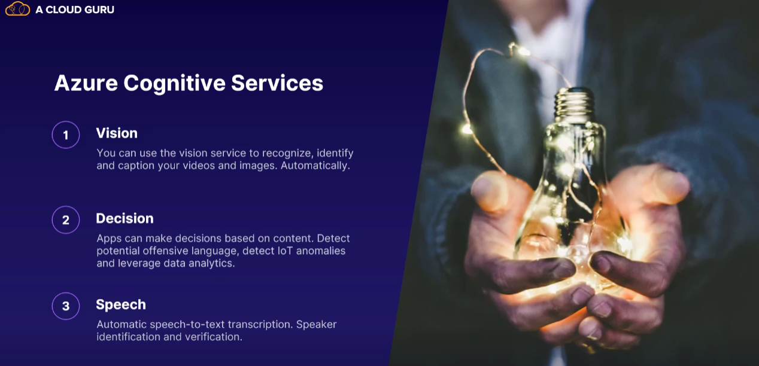

Azure Machine Learning Studio

* This is a visual tool that can help you manage all of your machine learning needs.
* It supports all the various programming languages, data sets, models, projects, and services that are available in Azure for machine learning.
* It has pre-made modules that you can just plug into your project and use straightaway.

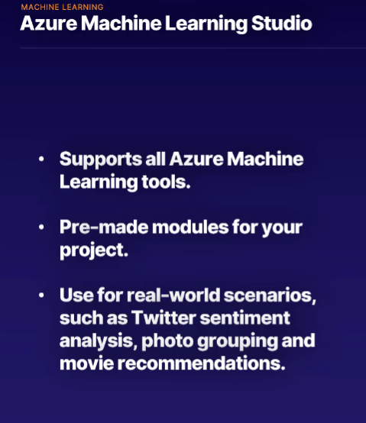

Machine Learing service

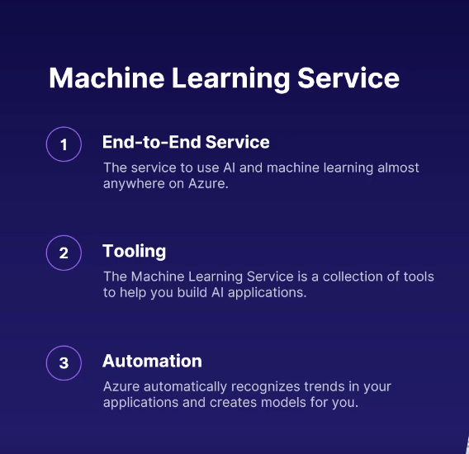

This is the end-to-end service for using machine learning pretty much everywhere on Azure.

It's a service that expands all of Azure and helps you use machine learning in more and better ways.

It's a range of tools to help you build machine learning into your products and Azure processes. And you get automated machine learning, which means Azure will pick up trends and processes automatically for you and create machine learning models that you can use.

So AI is about better products and better customer service, much more than taking over the world.

Serverless

Serverless refers to the fact that you aren't managing any servers yourself, at all.

Your applications are running on someone else's server. Serverless is an extreme version of Platform as a Service, or PaaS.

Azure Functions::

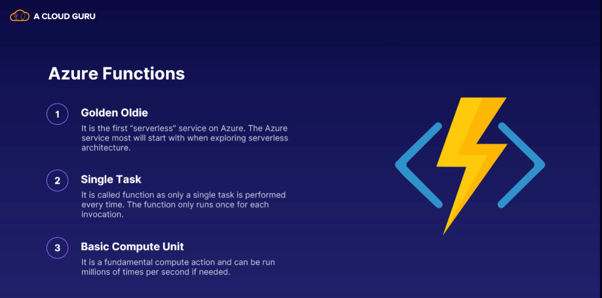

Logic app::

Logic Apps are a way to connect many different and varied systems both within and outside Azure.

You can integrate apps, data, systems, and services across enterprises or organizations.

A Logic App can schedule, automate, and orchestrate tasks, business processes, and workflows.

>>> For example, every time a tweet is made from an account, trigger some process.

No coding skills are needed at all. All the connections and integrations are fully customizable in the Azure portal.

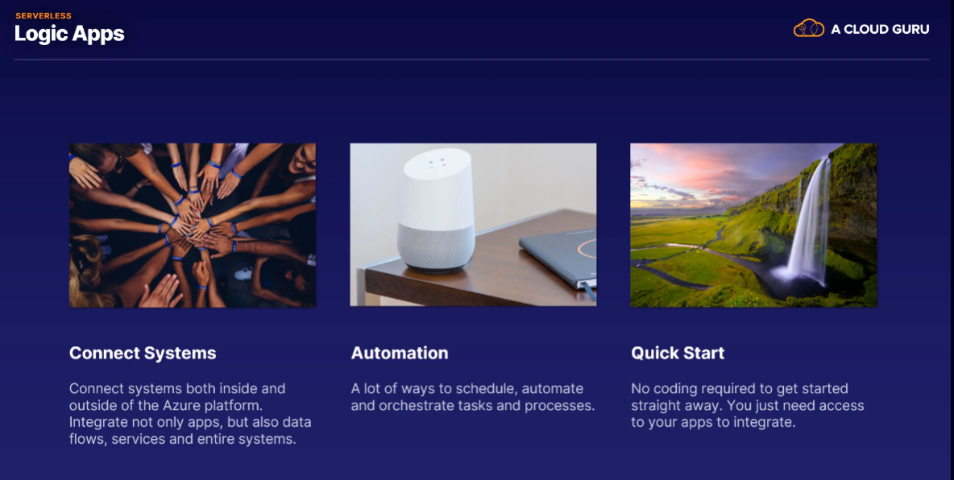

>>>> For example, every time a new order is created in your ordering system, you can create a Logic App that creates a record for how long it took.

It inserts that into a database and sends an email to the person in charge.

You can also have a conditional path, so if, for example, the order was over $100, you also send a different email to customer service asking them to thank the customer.

You can connect a ton of different applications either manually or using templates. There's no code needed, no servers to set up, and you can get started very quickly.

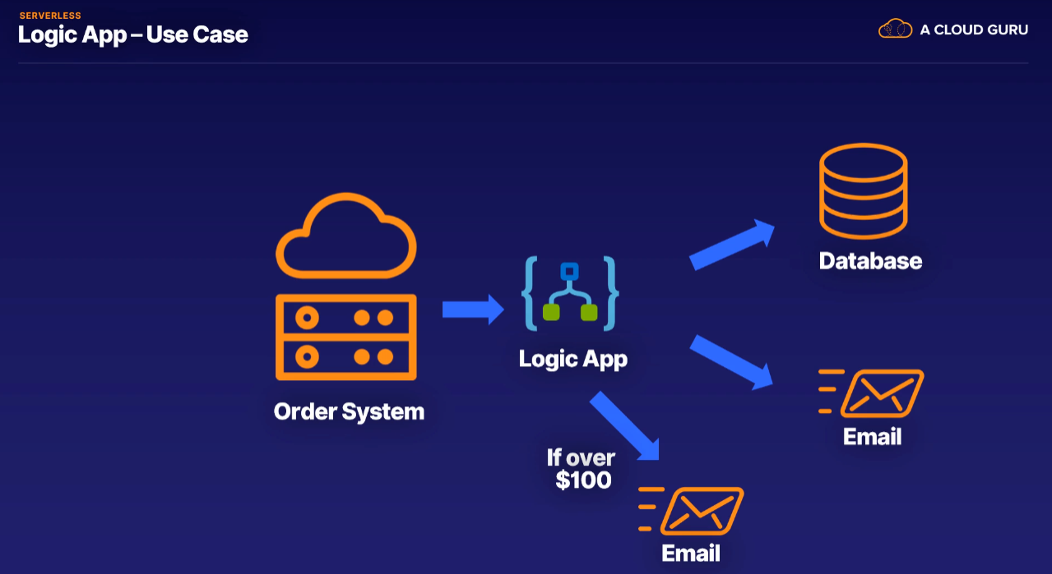

Event Grid:::

What is an event?

In computing terms, It is when an application or process wants the world (being other connected applications) to know that something happened.

* Event Grid is a routing service for connected applications, making sure events are sent and received fast and accurately.
* It's a serverless service because you don't manage any infrastructure.
* Event Grid makes setting up complex architecture of interconnected disparate services a lot simpler.

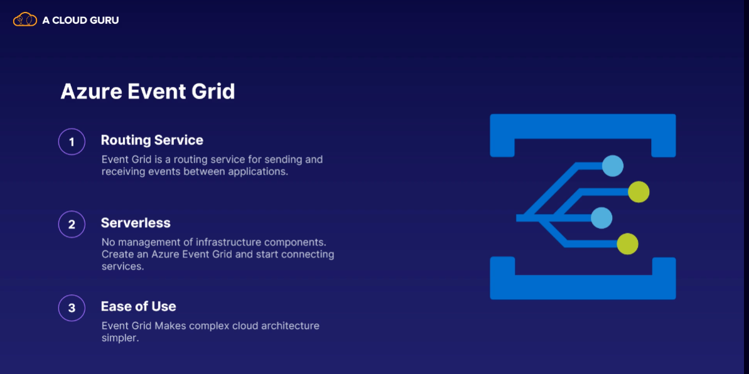

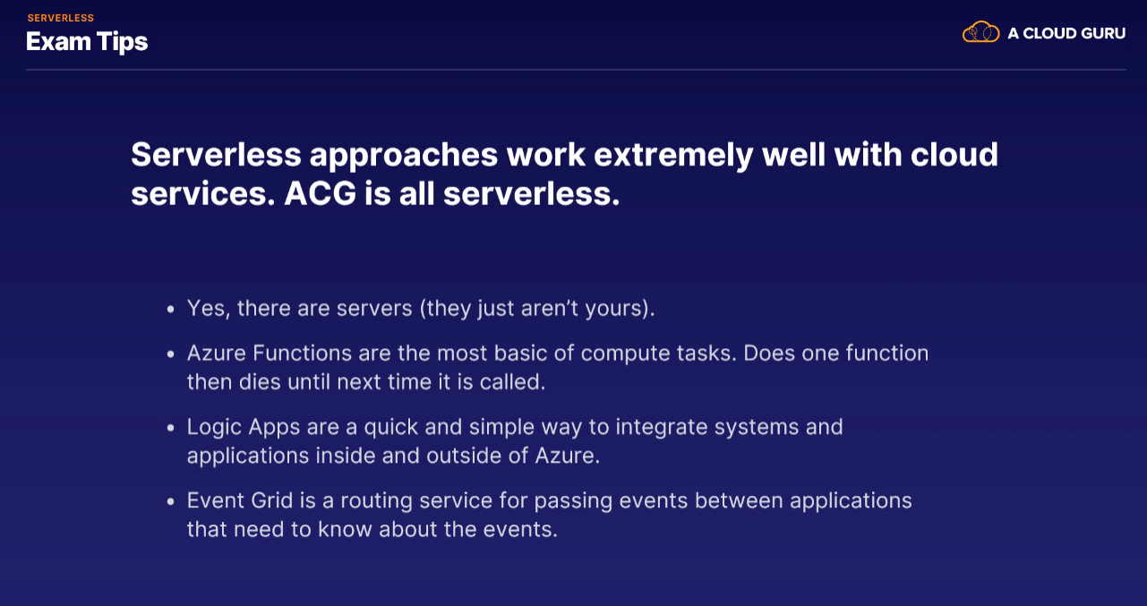

DevOps

DevOps is the work between development and production



One – Azure Devops

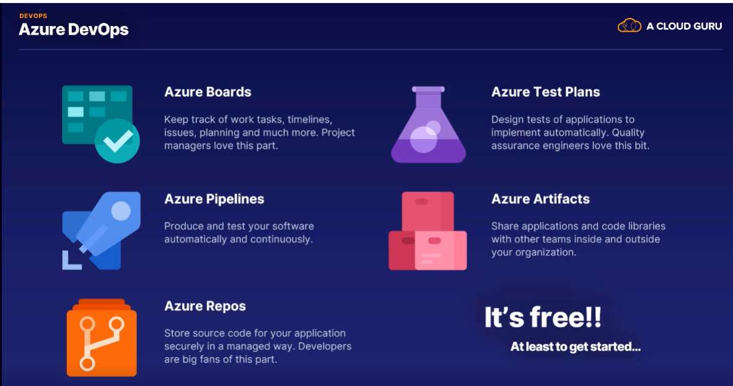

Two – Azure DevTest labs

DevTest Labs focuses on the environment they run on.

